ASSESSMENT TOOL 1 – INDUSTRY PROBLEM TASK
Course: Artificial Intelligence | Code: CSA17 | CO4
Student Name: BATHALA HEMANTH KUMAR
Register Number: 192324238
Industry scenario: A healthcare company has patient records containing age, blood pressure, cholesterol, glucose level, BMI and family history. The goal is early diabetes diagnosis and personalised treatment recommendation using Diet, Exercise, Medication or Monitor.

Task 1: Data Preparation & Inductive Learning

1(a) Inductive learning approach
Inductive learning learns a general rule from labelled patient examples and applies it to unseen patients. The target variable is Diabetes (0 = non-diabetic, 1 = diabetic).
Feature | Justification
Glucose level | Strong indicator of glycaemic status and highly relevant to diabetes classification.
BMI | Represents obesity-related metabolic risk.
Age | Captures age-related variation in diabetes risk.
Blood pressure | Adds cardiometabolic risk information.
Family history | Represents inherited susceptibility.

1(b) Class imbalance
SMOTE is recommended on the training set because it creates synthetic minority-class examples rather than simply duplicating diabetic records. The test set must remain unchanged. Class weights can be used as an additional comparison.

1(c) 70:30 split and preprocessing
A stratified 70:30 split provides sufficient data for learning while retaining an independent test set. Preprocessing includes missing-value imputation, numerical scaling where required, categorical/binary encoding, outlier inspection, and fitting all preprocessing transformations only on the training data.

Task 2: Decision Tree for Diagnosis

2(a) Tree and root node
A worked demonstration was created because the uploaded assessment does not provide a patient dataset. It uses 300 synthetic records and a Gini-based tree. The learned root feature was Glucose. The root is selected because its split produces the largest impurity reduction at the top level.
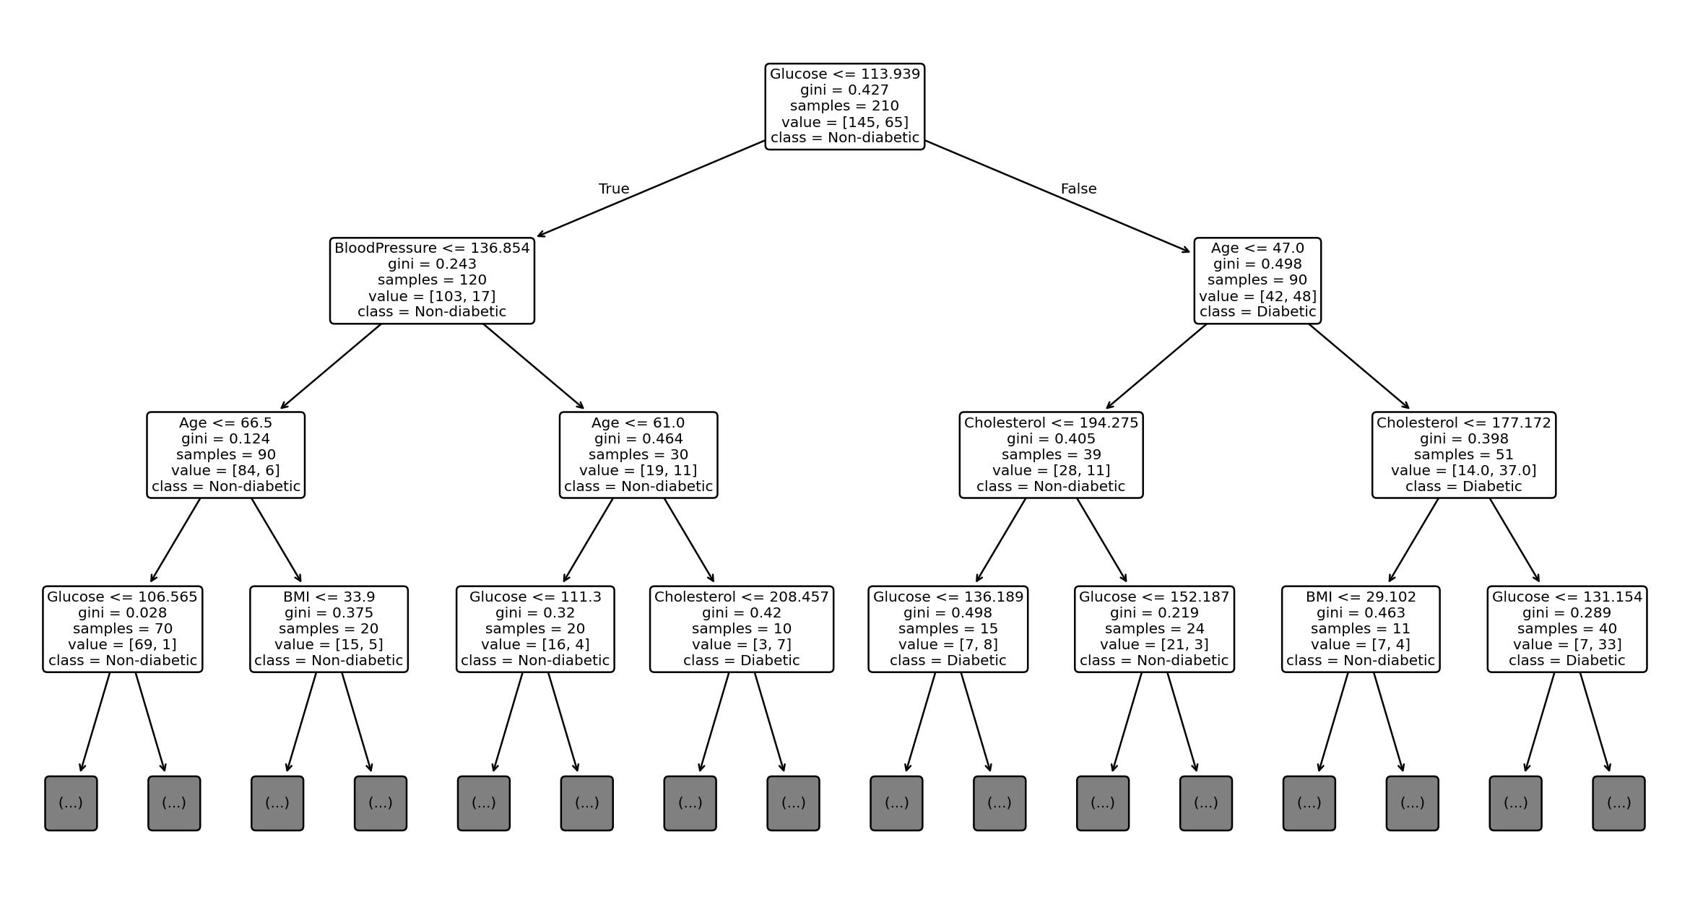
Figure 1. Worked Decision Tree demonstration.

2(b) Evaluation
Metric | Worked result
Accuracy | 0.689
Precision | 0.500
Recall | 0.500
F1-Score | 0.500
False negatives are diabetic patients predicted as non-diabetic. Clinically, they are important because a missed case may delay confirmatory testing and treatment. Recall-oriented threshold selection, class weighting, SMOTE and clinical review can help reduce them.

2(c) Post-pruning
Cost-complexity pruning removes branches that add complexity without sufficient validation benefit. Pre-pruning limits tree growth during training; post-pruning grows a tree and then removes weak branches. In clinical deployment, the preferred model should balance sensitivity, calibration, stability and interpretability.

Task 3: Statistical Learning for Risk Stratification

3(a) Logistic Regression comparison
Model | Accuracy | AUC-ROC
Decision Tree | 0.689 | 0.708
Logistic Regression | 0.800 | 0.895
Logistic Regression is preferable when probability interpretation, simpler governance and approximately linear relationships are important. A Decision Tree is useful when nonlinear thresholds and interactions are important.

3(b) Feature importance
Model | Top 3 predictors
Decision Tree | Glucose, Age, Cholesterol
Logistic Regression | Glucose, Age, BloodPressure
Different rankings are possible because the tree uses impurity reduction while Logistic Regression uses coefficient magnitude after scaling.

Task 4: Reinforcement Learning for Treatment Recommendation

4(a) MDP
Component | Definition
States | Stable/low risk, elevated risk, poor control, improving.
Actions | Diet, Exercise, Medication, Monitor.
Reward | Positive for health improvement; negative for deterioration or unsafe outcomes.
Transitions | Movement between health states after actions, learned from longitudinal data and constrained by clinical knowledge.

4(b) Q-Learning
Q-learning update: Q(s,a) = Q(s,a) + α[r + γ max Q(s',a') − Q(s,a)]. Example hyperparameters: α=0.1, γ=0.9, ε=0.2.
Iteration | State | Action | Reward | Old Q | Target | New Q
1 | Stable | Monitor | -1 | 0.00 | -1.00 | -0.10
1 | Stable | Diet | 2 | 0.00 | 2.00 | 0.20
2 | Stable | Diet | 3 | 0.20 | 3.00 | 0.48
For the required five or more patient episodes, the same update should be applied to longitudinal patient trajectories. Convergence can be defined using a small maximum Q-table change for several consecutive episodes plus stabilisation of average reward.

4(c) Final policy and ethics
Patient state | Illustrative policy
Stable / low risk | Monitor
Elevated risk | Diet / Exercise
Poor control | Medication + clinical review
Improving | Continue effective intervention and Monitor
Deployment requires patient safety, bias testing, explainability, privacy, auditability and clinician oversight. RL should not autonomously prescribe treatment without rigorous prospective validation and governance.

